**SleepyFlyR User Guide**

**1 Sample Data**

SleepyFlyR offers two sample data files and a user guide for user to quickly learn the functions within the package. Both sample data files use male w1118 fly as test subject, and experiments were carried out under LD condition with 12 hours light and 12 hours darkness. In sample data one (Fig.1a), thirty-two flies were mounted on DAM2 module at 4 PM on “4 Jul 22”, experiment started from “5 Jul 22” and lasted for five days. Baseline data was collected from Day 1 to Day 3. Sleep promotion device was turned on for 24 hours on Day 4. Recovery data was recorded on Day 5. In sample data two (Fig.1b), thirty-two flies were mounted on DAM2 module at 5 PM on “28 Dec 20”, experiment lasted for seven days from “29 Dec 20” to “5 Jan 21”. Baseline data was collected on Day 1, Day 2 and the light phase of Day 3. Sleep deprivation device was turned on during the dark phase of Day 3. Recovery data was gathered from Day 4 to Day 7.

User can use the sample data for practice and try different settings. The following user guide is based on sample data one.

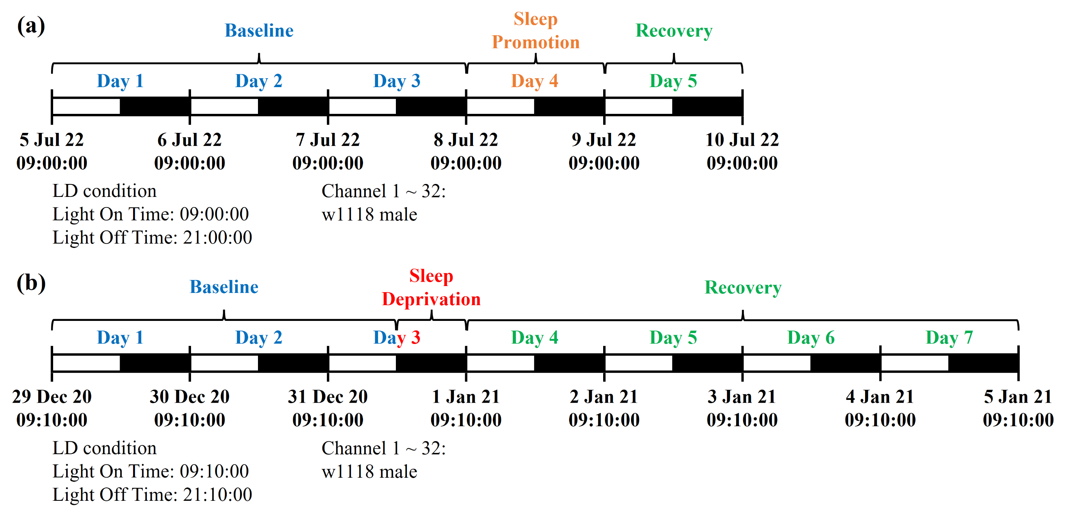

Fig.1 Information of sample data

**2 Methods**

**2.1 Running Environment**

SleepyFlyR is developed in R (version 4.2.1) and RStudio (version 2023.03.0+386) on Windows 11 system. SleepyFlyR, SleepFlyR UI script, two sample data files and a user guide are available on the GitHub repository ([GitHub - SoapMou/SleepyFlyR: SleepyFlyR: an R package for sleep and activity analysis in Drosophila](https://github.com/SoapMou/SleepyFlyR)). Steps for using this package includes: (1) Download and install R and RStudio. (2) Download SleepyFlyR (including a compressed file for SleepFlyR package and an R file for SleepFlyR UI script). (3) Open SleepyFlyR UI script in RStudio and install SleepFlyR package. (4) Configure “File Directory” and “Parameters”. (5) Choose one or multiple functions and customize settings. (6) Click “Source” on top right of the script box to initiate analysis. The user guide uses sample data one as example for demonstrating functions within the package.

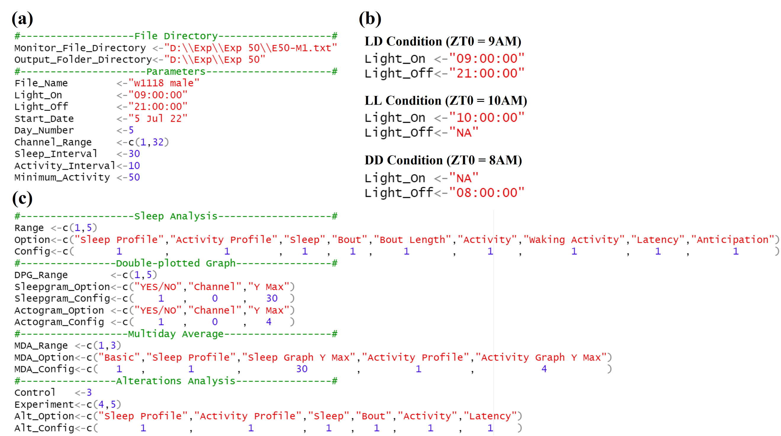

Fig.2 Screen shot of SleepFlyR UI script

(a) Upper part of UI script for general input. (b) User can choose LD, LL or DD condition by changing the value of “Light On” and “Light Off”. (c) Lower part of UI script where user selects specific analysis to perform. (Published data in JSJTU)

**2.2 File Directory**

“File Directory” is the first part of UI script where user sets the location of the monitor file created by DAM3 software at “Monitor File Directory”. The user should note that the file for analysis needs to be the monitor file directly generated by DAM3 software at 1 minute reading interval and should not be processed by file scan software - DAMFileScan. The user also needs to designate a folder for results to be stored at “Output Folder Directory” (Fig.2a). Here are the descriptions for several critical data in monitor file (Fig.3): (1) Column 1: reading number, (2) Column 2-4: date (Day/Month/Year), (3) Column 5: time (Hour/Minute/Second), (4) Column 12: light indicator (“1” for light-on, “0” for light-off), (5) Column 13-44: total activity during one reading interval for each channel.

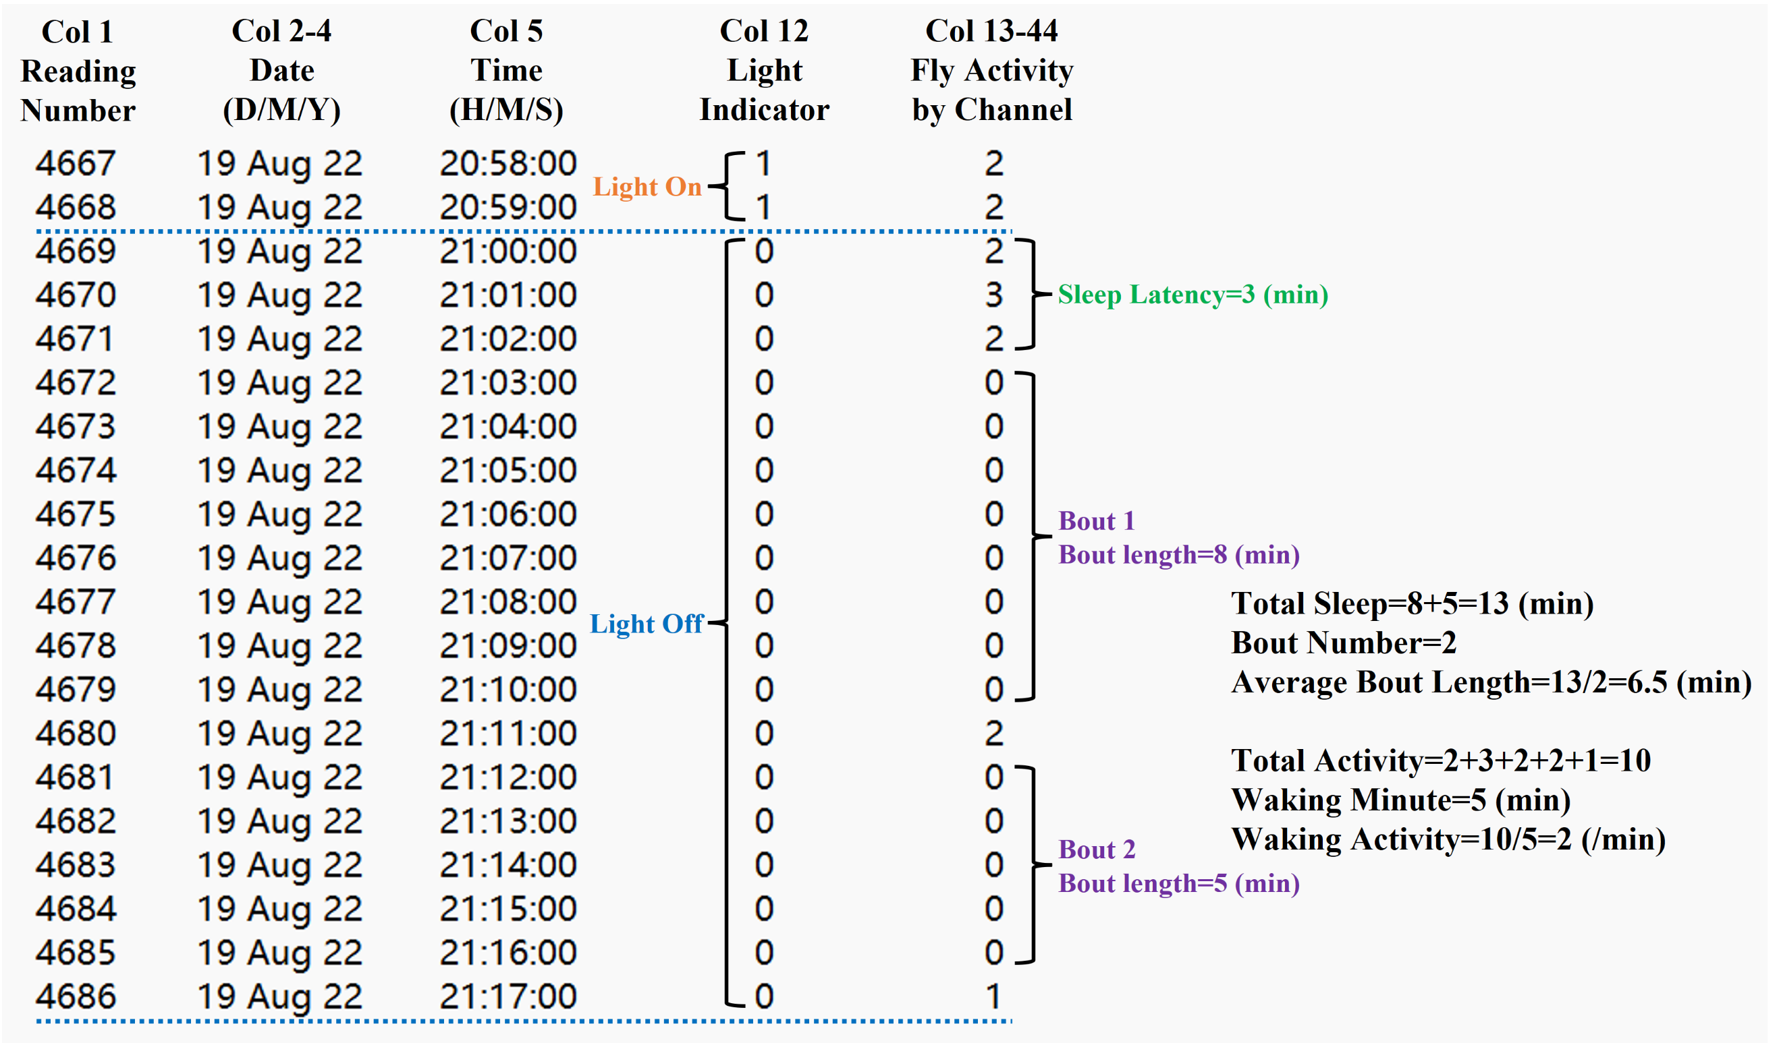

Fig.3 Calculations of sleep and activity

The number of beam crosses (which represents activity) in every one minute for each channel is stored in column 13 to column 44 of the monitor file. In column 12, light phase and dark phase are represented with “1” and “0”, respectively. Sleep in fly is defined as a period of behavioral immobility that last for 5 minutes or more. (Published data in JSJTU)

**2.3 Parameters**

In “Parameters”, the user is required to enter several global parameters before conducting analysis. Detailed descriptions for these parameters are elucidated as follows (Fig.2a):

2.3.1 File Name

This is where user labels the data to be analyzed. It can be the genotype of files, group name, monitor number, or experiment descriptions, etc. Male w1118 flies were used in sample data one, we can enter “w1118 male” as file name.

2.3.2 Light On (24-hour format, clock time)

This is the time when light is turned on for each day throughout the experiment. The default value is 9 AM (09:00:00) and it is accurate to the minute. SleepyFlyR provides versatile analysis for experiments under different lighting conditions including normal light-dark cycle (LD), constant light (LL) and constant dark (DD). For LD condition, the user needs to specify both “Light On” and “Light Off”, but the duration of light or dark phase is not limited to 12 hours (Fig.2b). For LL condition, “Light Off” needs to be set as “NA” and user can enter a value for “Light On” (Fig.2b). For both LD and LL, “Light On” serves as the Zeitgeber Time 0 (ZT0). Light on time in sample data one is “09:00:00”.

2.3.3 Light Off (24-hour format, clock time)

This is the time when light is turned off for each day throughout the experiment. The default value is 9 PM (21:00:00) and it is accurate to the minute. For DD condition, “Light On” needs to be set as “NA” and user can enter a value for “Light Off” (Fig.2b). “Light Off” serves as the ZT0 under DD condition. Light off time in sample data one is “21:00:00”.

(Note: The bar indicating light (white bar) and dark (black bar) phase in graphs generated by SleepyFlyR will also be adjusted accordingly (Fig.6d).)

2.3.4 Start Date (Day/Month/Year format)

The monitor file may contain data from previous experiment when user started recording without deleting the file of last experiment. Although the user can manually delete irrelevant data, this action is troublesome and risky, which may compromise the monitor file. To resolve this problem, SleepyFlyR allows the user to enter “Start Date” in the format of Day (number), Month (English abbreviation), and Year (number) separated with space, which in combination with ZT0 time, determines the starting point of data for further analysis. Experiment in sample data one started from “5 Jul 22” which is the “Start Date” of analysis.

(Note: ZT0 time needs to be included in the data collected on “Start Day”. For example, if the first row in monitor file was recorded at 2 PM on “16 Aug 22” and ZT0 time is 9 AM, “Start Day” should be set as “17 Aug 22” because “09:00:00” was not included in the data updated on “16 Aug 22”.)

2.3.5 Day Number

The DAM3 software keeps updating monitor file even when DAM2 module is not plugged in. Data with warning code “51” was generated when software was not closed after DAM2 module disconnected. In order to exclude invalid data from analysis, user needs to set the duration of current experiment by entering a positive integer in “Day Number”. Sample data one contains fly activity data from “5 Jul 22” to “10 Jul 22”, and the “Day Number” would be five.

(Note: “Day Number” plus the ZT0 time of “Start Day” should not exceed the last record in monitor file. For example, if the first ZT0 time is at “09:00:00” on “17 Aug 22” and the last record was logged at “08:00:00” on “25 Aug 22”, the maximum “Day Number” will be 7.)

2.3.6 Channel Range

The activity of thirty-two files can be simultaneously monitored on a single DAM2 module, but they are not necessarily of the same genotype or the same group. Therefore, the user can assign the channel range by entering two numbers for beginning channel and ending channel respectively. The activity of thirty-two male w1118 flies were recorded in sample data one, meaning that the “Channel Range” should be “1,32”.

2.3.7 Sleep Interval (minutes)

SleepyFlyR generates sleep profiles data and plots sleep pattern by calculating the sleep duration per “Sleep Interval” min for each channel. “Sleep Interval” needs be a positive integer and 1440 should be divisible by it. The default value for “Sleep Interval” is 30.

2.3.8 Activity Interval (minutes)

SleepyFlyR generates activity profiles data and plots activity pattern by calculating the average activity per minute in every “Activity Interval” min for each channel. “Activity Interval” needs be a positive integer and 1440 should be divisible by it. The default vale for “Activity Interval” is 10.

2.3.9 Minimum Activity

This value is used to determine whether fly in certain channel is active or inactive throughout the whole experiment (from “Start Day” to the last day of “Day Number”). Flies with full day activity smaller than “Minimum Activity” are considered as deceased and will not be included in the calculation of mean, standard deviation (SD), and standard error of mean (SEM). But their data is still presented in result tables. The default vale for “Minimum Activity” is 50.

(Note: Calculation of lifespan starts on “Start Date”, and lifespan of each channel is determined by “Day Number” and “Minimum Activity”.)

**3 Sleep Analysis**

A fly is considered to be sleeping when it maintains quiescence behaviorally for five minutes or more, meaning that any record consisted of five or more consecutive zeros (reading interval = 1 min) in monitor file can be recognized as a sleep bout (Fig.3). SleepyFlyR provides comprehensive analysis for each channel in every 24 hours within a given range, which is also accompanied by the mean, SD, and SEM of multiple channels that are deemed to be active throughout “Day Number”.

To conduct sleep analysis, the user needs to first set the day range for “Sleep Analysis” by entering the first day and the last day in “Range”, in which the number cannot exceed “Day Number” (enter “0” for not conducting sleep analysis) (Fig.2c). Next, the user can select certain results in “Option” for output by entering “1” in the corresponding location in “Config” (enter “0” for not generating this result). The results of “Sleep Analysis” are described below. In order to analyze all data in sample data one, we should set “Range” as “1,5”.

Profile data (Fig.4):

(1) Sleep Profile: sleep duration in every “Sleep Interval” min for each channel and every day. For example, when “Sleep Interval” is 30, the “Sleep Profile” of a single channel in one day consists of 48 numbers with each number representing the sleep length in one specific interval. (2) Activity Profile: average activity per minute in every “Activity Interval” min for each channel.

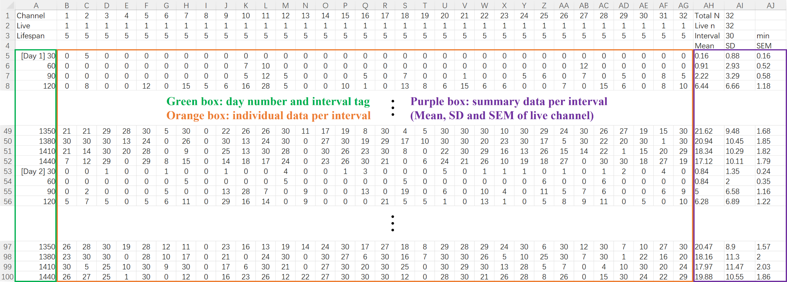

Fig.4 Profile data of Sleep Analysis

The profile data of sleep and activity are provided in Sleep Analysis. Day number and interval tag are shown in green box which can help user to locate data. The profile data contains both individual data per interval (orange box) and summary data per interval (purple box). (Published data in JSJTU)

Non-profile data (Fig.5):

(3) Sleep: sleep duration for each channel. (4) Bout: number of sleep bout for each channel. (5) Bout Length: a single bout length is the number of zero value in a sleep bout. “Bout Length” calculates the average bout length (total sleep divided by bout number), which evaluates the sleep maintenance of fly. (6) Activity: total activity for each channel. (7) Waking Activity: waking minute is the number of all non-zero value in fly activity data. “Waking Activity” is the average activity per waking minute (total activity divided by waking minute). Waking activity measures fly’s locomotor ability during waking period. (8) Latency: sleep latency marks the number of minutes for a fly to enter the first sleep bout after light-off, which is a good indicator of the speed of sleep initiation and whether a fly has difficulty in falling sleep. (9) Anticipation: when entrained under 12h/12h LD condition, the locomotion of the fly exhibits diurnal oscillation. Morning activity peak and evening activity peak can be observed before light-on and light-off, respectively, suggesting that the fly anticipates the transition between the light and dark phases. Anticipation index is defined as the total activity in 3 hours before light/dark transition divided by the total activity in 6 hours before light/dark transition. A larger anticipation index indicates more significant activity peak before light-on or light-off.

(Note: analysis results for every 24-hour (“Full-day”), every light phase (“Day”), and every dark phase (“Night”) are provided in (3) to (7). Under LL and DD condition, results for dark phase and light phase are presented with “0” respectively. “Latency” and “Anticipation” are calculated only under LD condition.)

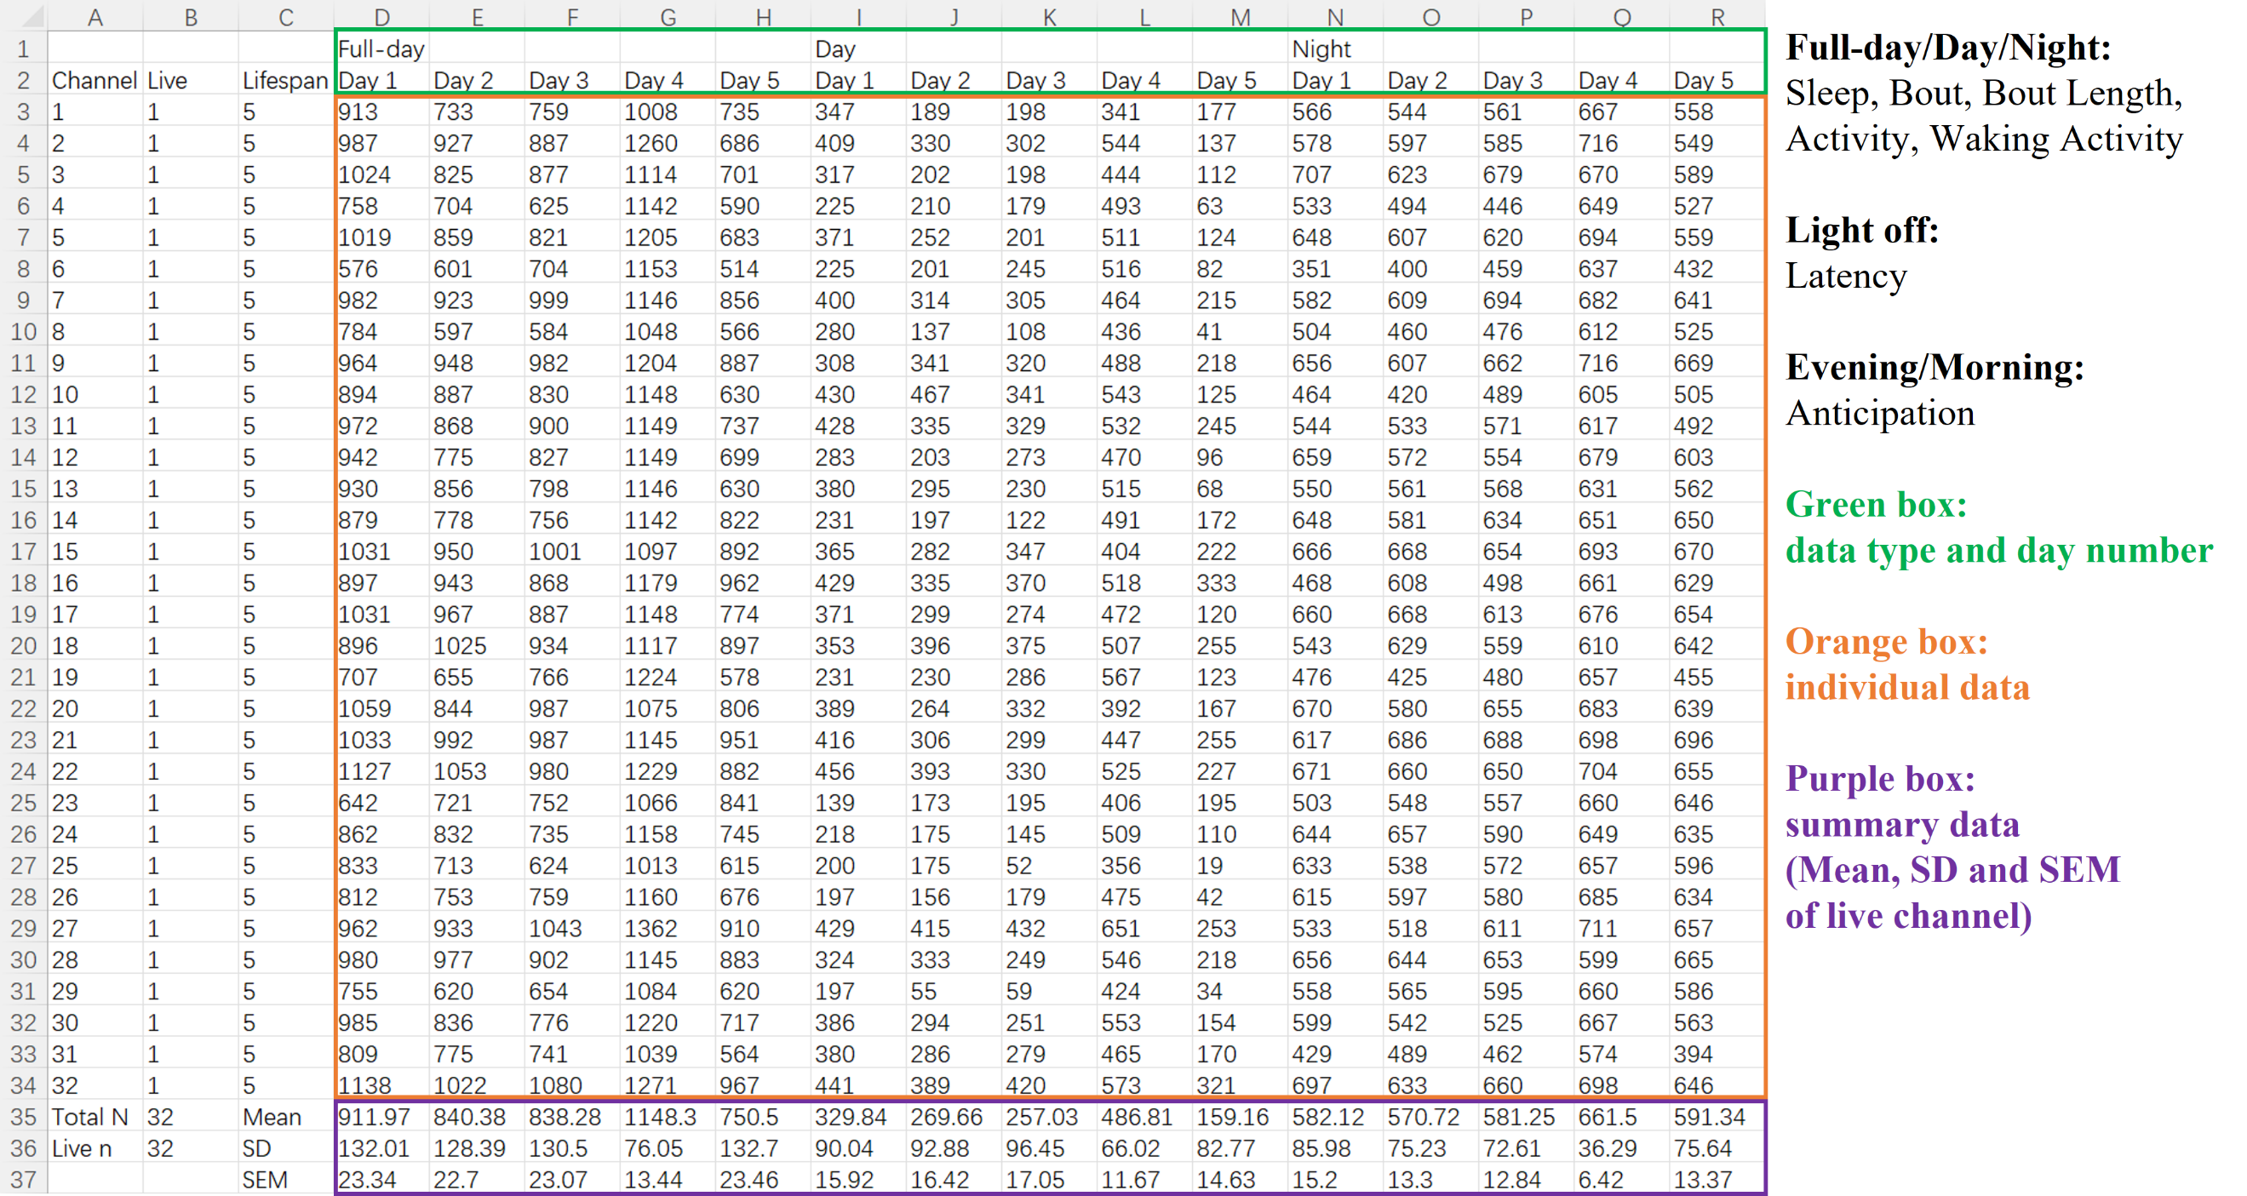

Fig.5 Non-profile data of Sleep Analysis

Non-profile data of Sleep Analysis includes “Sleep”, “Bout”, “Bout Length”, “Activity”, “Waking Activity”, “Latency”, and “Anticipation”. These results are stored in separate files. Information concerning channel number, whether fly remains active throughout the experiment and lifespan are provided in the first three column. Green box indicates data type and day number. Individual data and summary data are shown in orange box and purple box, respectively. (Published data in JSJTU)

**4 Double-plotted Graph**

This function generates double-plotted sleep patterns (sleepgram) and activity patterns (actogram), with day number placed alongside the graph and a bar for light phase and dark phase underneath it (Fig.6ab). User needs to set the day range by entering the first day and the last day in “DPG Range”. The number for last day cannot exceed “Day Number” (enter “0” if double-plotted graph is not needed) (Fig.2c).

The user is also required to configure sleepgram and actogram in the corresponding “Config” section: (1) YES/NO: enter “1” for outputting figure. (2) Channel: this software is able to analyzes sleep and activity patterns of a single fly (by entering the channel number) or across “Channel Range” (by entering “0”). (3) Y Max: set the limit of y axis in double-plotted graph. It is advised that “Y Max” of sleepgram is equal to or larger than “Sleep Interval”. And the default “Y Max” of actogram is 4. In order to generate double-plotted graphs of all data in sample data one, “DPG Range” needs to be set as “1,5”.

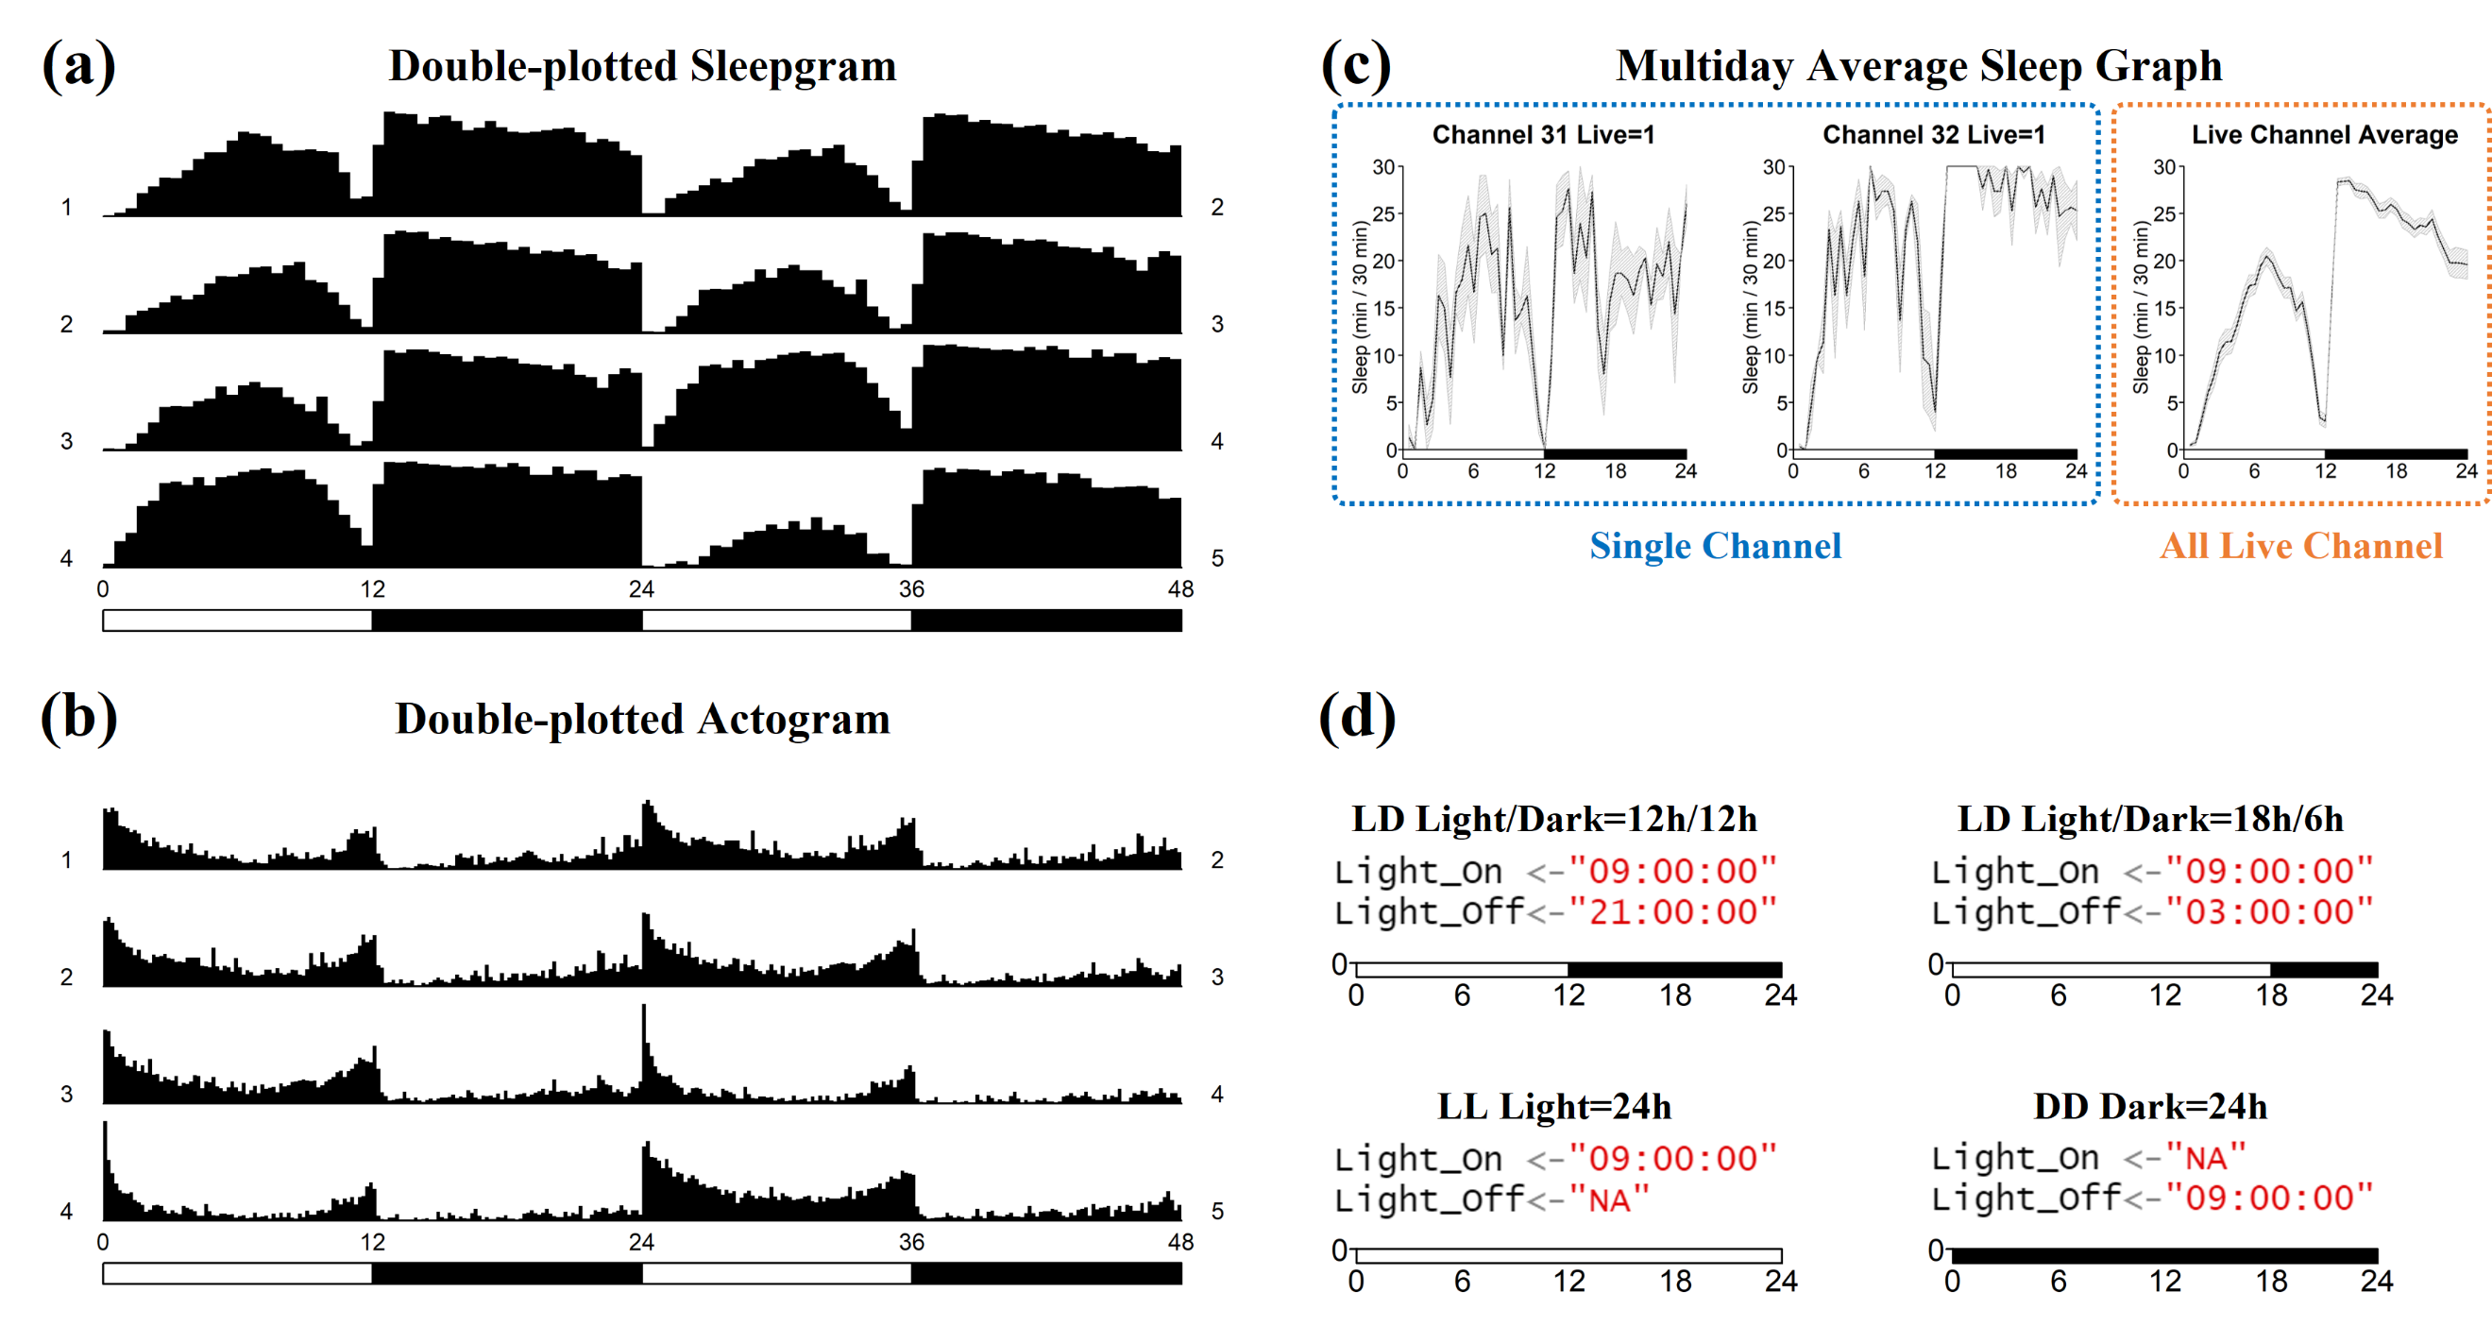

Fig.6 Figures generated by SleepFlyR

(a)(b) Double-plotted sleep patterns and activity patterns with day number alongside the graph and a bar indicating light phase and dark phase. (c) Graphs of sleep profile across multiple days. The title of single channel figure offers the information of channel number and fly’s survivorship. (d) The style of bar underneath graphs is automatically adjusted as user chooses different entrainment conditions. (Published data in JSJTU)

**5 Multiday Average**

This function calculates the averaged data among multiple days within a given range for each channel and interval. It also plots averaged sleep/activity patterns for individual channel as well as patterns of all live channels. Firstly, user needs to set the day range in “MDA Range” which cannot exceed “Day Number” (enter “0” for not generating multiday average results, while enter two identical number to analyze the data in a single day) (Fig.2c). Baseline data was collected from Day 1 to Day 3 in sample data one, we can generate multiday averaged baseline data by setting “MDA Range” as “1,3”. Then, user is required to specify the following parameters:

(1) Basic (Fig.7): enter “1” for outputting basic results which include the averaged data of “Sleep”, “Bout”, “Bout Length”, “Activity”, “Waking Activity”, “Anticipation”, and “Latency”.

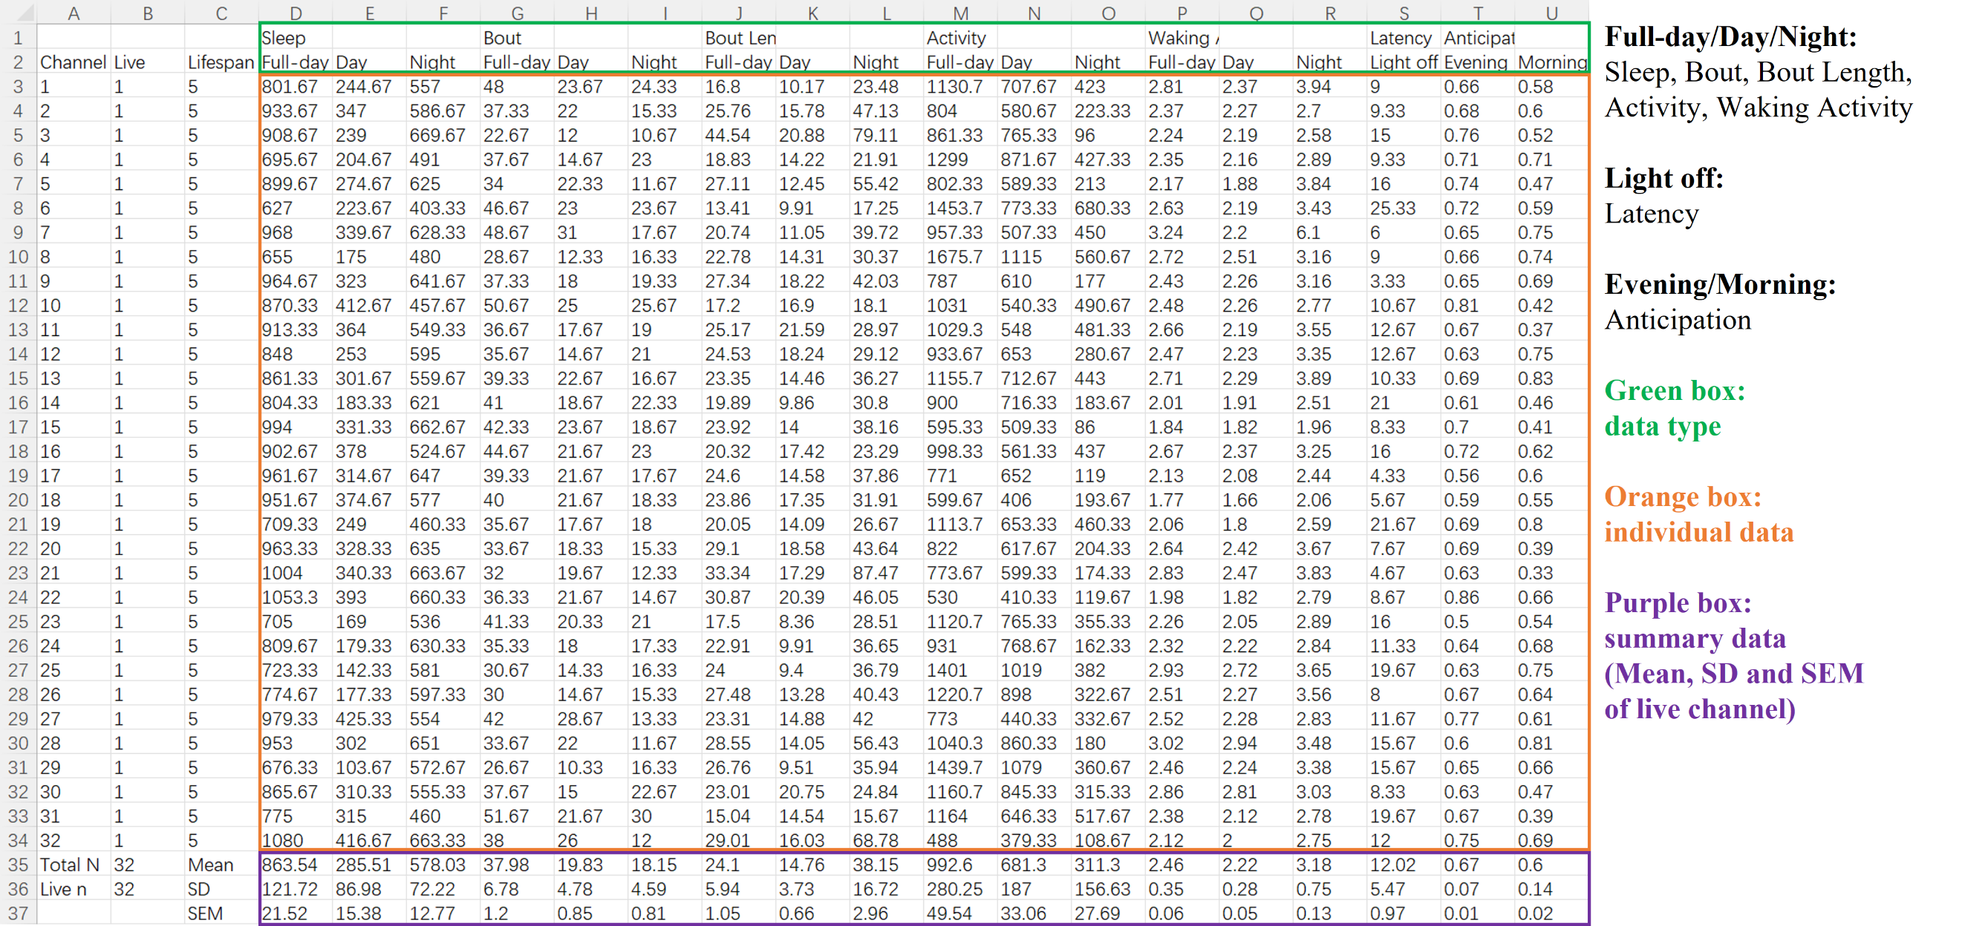

Fig.7 Basic data of Multiday Average

Multiday Average data of “Sleep”, “Bout”, “Bout Length”, “Activity”, “Waking Activity”, “Latency”, and “Anticipation” are stored in a single file. Green box indicates data type. The multiday averaged individual data and the summary of individual data are shown in orange box and purple box, respectively. (Published data in JSJTU)

(2) Sleep Profile (Fig.8): in multiday averaged sleep profile, mean/SD/SEM results of sleep duration in each “Sleep Interval” min across “MDA Range” are provided, with the mean result being further averaged across flies and shown on the right side of table. Enter “1” to output averaged sleep profile result.

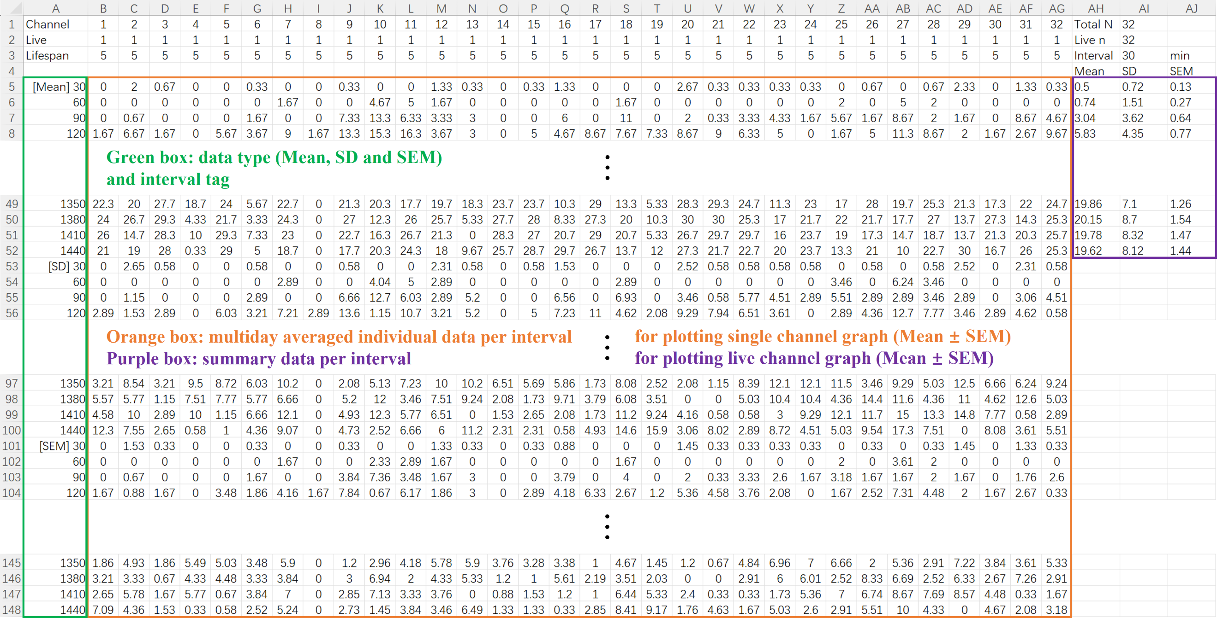

Fig.8 Profile data of Multiday Average

The profile data of sleep and activity are provided in Multiday Average. Data type and interval tag are shown in green box which can help user to locate data. Multiday averaged individual data per interval as well as its SD and SEM are provided in orange box, which is used for plotting the profile figure of single channel. Purple box contains the summary of individual data which is used for plotting the profile figure of all live channel. (Published data in JSJTU)

(3) Sleep graph Y Max: in addition to “Sleep Profile”, figures of multiday averaged sleep patterns for each channel and across all channels are also plotted (Fig.6c). User can customize the limit of y axis in the figure generated by “Multiday Average”.

(4) Activity Profile: see descriptions in “(2) Sleep Profile”.

(5) Activity graph Y Max: see descriptions in “(3) Sleep graph Y Max”.

(Note: the minimum ticks on the y axis in the figures of sleep patterns and activity patterns are 5 and 1, respectively. Therefore, “Sleep graph Y Max” and “Activity graph Y Max” should be divisible by the corresponding tick.)

**6 Alterations Analysis**

To study sleep homeostasis in flies, researchers often use strong mechanical vibration to induce sleep deprivation (SD) which is usually accompanied by a sleep rebound after SD. Genetic tools including *UAS-dTrpA1*, *UAS-shits* are frequently used to activate or silence neurons under different temperature conditions and may further affect sleep. Therefore, calculating the changes of sleep and other parameters is crucial in the abovementioned scenarios. SleepyFlyR provides a convenient tool for user to analyze the differences of sleep parameters between baseline and experiment. Profile result offers alteration data (Fig.9). Both baseline data and alteration data are provided in non-profile result (Fig.10).

Instructions for conducting alterations analysis include (Fig.2c): (1) enter the day number of baseline data (for example: before sleep deprivation, restrictive temperature) (enter “0” for not performing alterations analysis). (2) enter the day number of experiment data (for example: sleep deprivation, sleep recovery, permissive temperature). (3) select the result for output by entering “1” in “Alt Config” (alterations analysis for “Sleep Profile”, “Activity Profile”, “Sleep”, “Bout”, “Activity”, and “Latency” are available in SleepFlyR). In sample data one, the last day of baseline data is Day 3, and we should enter “3” in “Control”. Sleep promotion experiment was performed on Day 4 and recovery data was collected on Day 5, therefore, “Experiment” should be set as “4,5” if we want to analyze the difference between baseline data and experiment data.

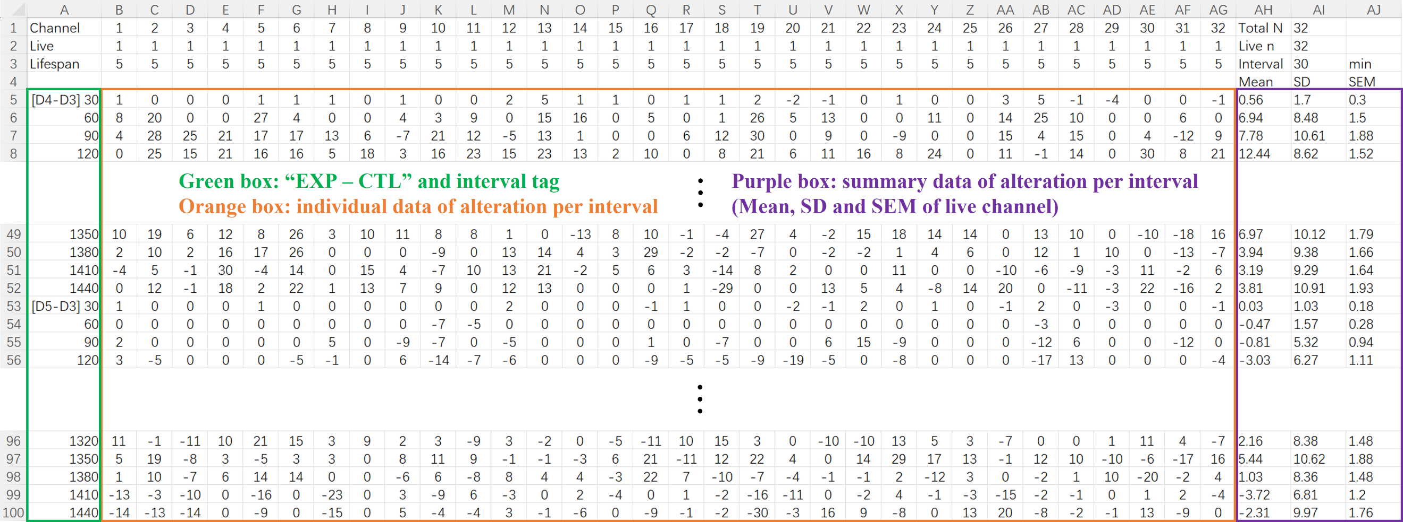

Fig.9 Profile data of Alterations Analysis

The profile data of sleep and activity are provided in Alterations Analysis. Alteration tag (day number of experiment minus day number of baseline, EXP - CTL) and interval tag are shown in the first column (green box) for user to easily locate data. Altered individual per interval and summary of altered individual per interval are provided in orange box and purple box, respectively. (Published data in JSJTU)

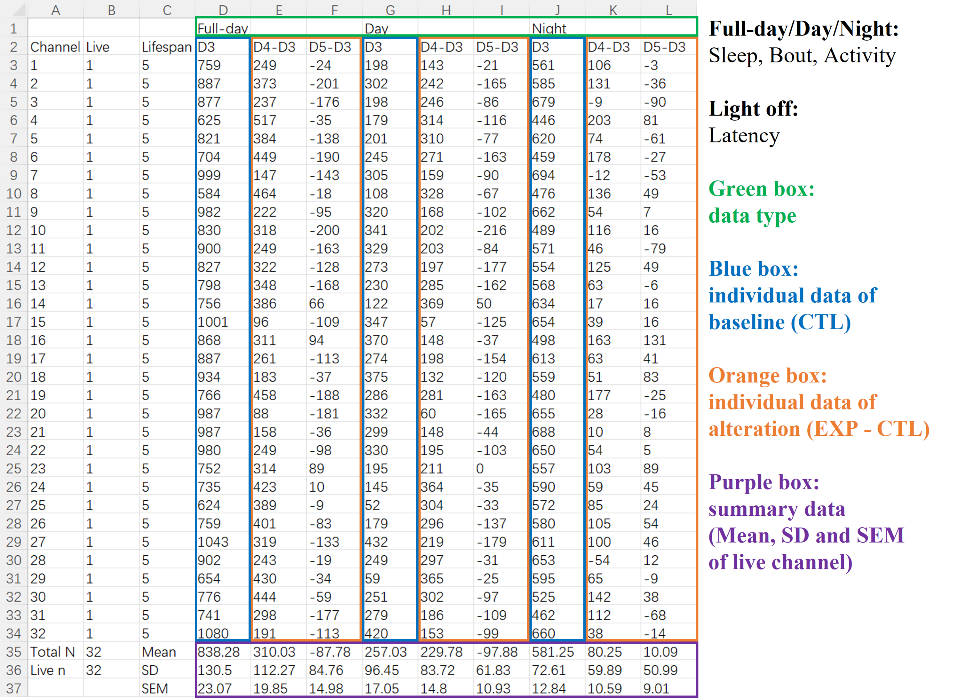

Fig.10 Non-profile data of Alterations Analysis

Non-profile data of Alterations Analysis includes “Sleep”, “Bout”, “Activity”, and “Latency”, which are stored in separate files. Green box indicates data type. The day number and individual data of baseline (CTL) are shown in blue box. The day number of experiment minus the day number of baseline (EXP - CTL) as well as altered individual data are shown in orange box. The summary data of both baseline and alteration are provided in purple box. (Published data in JSJTU)

**7 Naming of Result Files**

SleepyFlyR stores result data in comma-separated values file (.csv), and plots graphs in bitmap format (.bmp). Files are named after the parameters that user enters. File name is consisted of several sections which are described as follows: (1) file name, (2) channel range or channel number, (3) day range or day number, (4) abbreviation of function - SA for sleep analysis, DPG for double-plotted graph, MDA for multiday average, Alt for alterations analysis, (5) sleep/activity interval, (6) y axis limit of figures. Aided by automatic naming, user can analysis monitor file using different parameters without overwriting previous results. An example of result files name is shown in Fig.11.

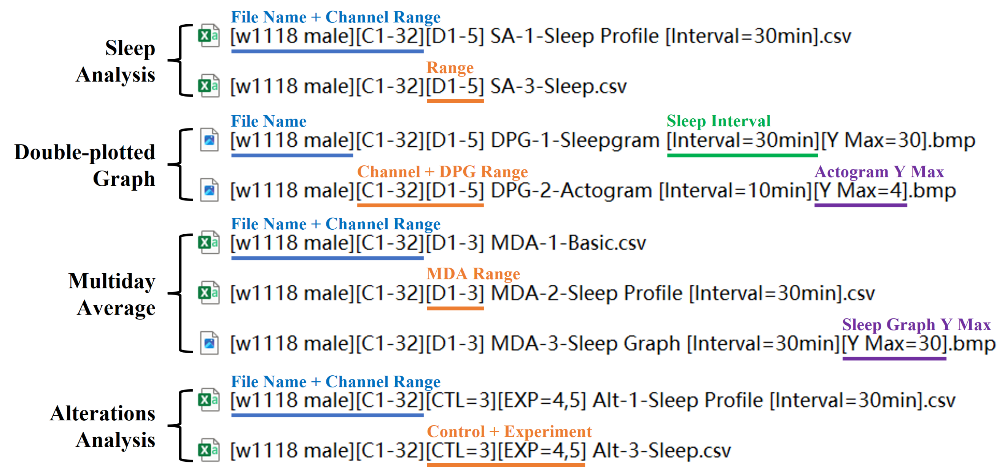

Fig.11 Naming of result files

(Published data in JSJTU)

**8 Using Other Softwares to Plot Graphs with Individual Data**

SleepyFlyR is capable of analyzing multiple sleep and activity parameters. It also generates figures that are difficult to plot including double-plotted graphs and multiday averaged profile. Unlike other programs that only offers summary data, SleepyFlyR provides both summary data and individual data which give user the freedom to generate figures that are easy to plot but highly variable using softwares such as GraphPad, Origin and Excel. Here is an example of using GraphPad to plot graphs with individual data from the analysis results of sample data one. Individual data for Fig.12a to Fig.12d come directly from “SA-3-Sleep”, “Alt-3-Sleep”, “SA-1-Sleep Profile” and “Alt-1-Sleep Profile” respectively (see Fig.11 for naming rules).

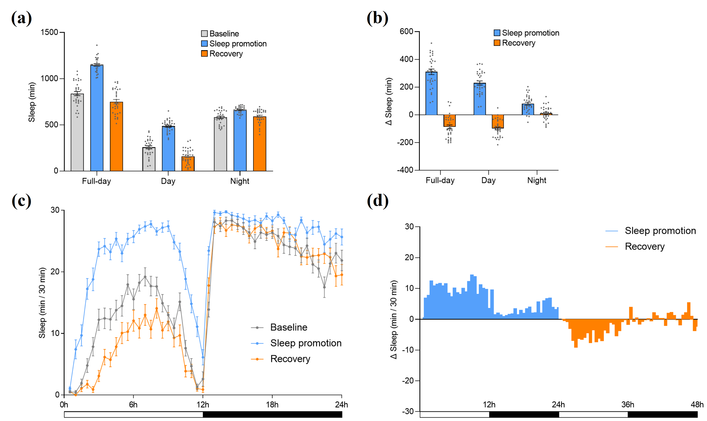

Fig.12 Graphs plotted with GraphPad

(a) Bar graph of sleep duration on Day 3 (baseline), Day 4 (sleep promotion), and Day 5 (recovery). (b) Bar graph of sleep alteration during “Sleep promotion” and “Recovery” compared to “Baseline”. (c) Sleep profiles of “Baseline”, “Sleep promotion” and “Recovery”. (d) Profiles of sleep alteration during “Sleep promotion” and “Recovery” compared to “Baseline”.